COVID Guidelines for Coaches
As we return to training at Hazlemere Youth Centre we have new measures to put in place as a club to make sure that all parents, gymnasts and coaches are working together to make the environment as Covid Secure as possible. We appreciate your support in helping us return to training safely!
GENERAL
- We would advise those coaches who are clinically vulnerable or who live with someone who is to hold off from returning to training at present.

- If you or anyone in your household is sick or shows any sign of Covid symptoms do not attend club but please inform Ruth immediately. You must follow the government guidelines and quarantine for 14 days or get tested. Please inform the club of the results of your test – you will be allowed back to coach again if it is negative and you are feeling better.

- You must socially distance at all times when arriving at and inside Hazlemere Youth Centre.

- You must wash your hands on entering the youth centre, when you leave and between each different class that you coach. Please also take your temperate as you arrive in the café area.

- We prefer you to arrive at club already changed and ready for work if at all possible, but understand this may not be possible during the week.

- If you do come to club on the bus or straight from school please make sure that you change into your coaching clothes in the disabled toilets and wash your hands thoroughly on arrival. You will then need to put the clothes you were wearing on the bus away in a bag then wash your hands again.

- Please bring all the food and drink that you will need at club with you as we are not allowed to use the kitchen to refill water bottles or use the microwave etc at the moment.

- You will need to wear a mask when entering the building, in the café area, corridors and toilets. You may take your mask off in the hall and do not need to wear it when setting up equipment, coaching or packing down equipment. Please inform Ruth before the start of term if you have a medical exemption in place regarding face masks – you will need to wear an exemption card around your neck at club.

- All coaches will be expected to help with the cleaning of equipment throughout sessions and in between different sessions. Each coach will have a cleaning kit to take around the gym with them stocked up with tissues, gloves, masks, hand sanitizer, cleaning spray and cloths, hand cream.

DROP OFF

- Doors will open 5-10 minutes before each class begins as it will be slow signing children in. Drop off will be via the front entrance of the youth centre and families will need to queue in a socially distanced manner sticking to the floor markings from the front entrance along the tall fence on the left and then close to the fence moving away from the youth centre towards the park. Council guidelines are that over 11s entering the centre must wear a face mask unless they are actively involved in the session so all parents should be wearing one when dropping a child off.

- Upon entering the building, the gymnasts must wash their hands for 20 seconds at the handwash station and all parents and siblings use the hand sanitizer provided. Once this is done, they may move forwards to the sign in desk if this is free where a coach (wearing a face visor) will sign the gymnast in and take their temperature before they enter the hall using the doors straight in front of the main entrance. Any child with a temperature reading of over 37.8° or who has a cough or is sneezing will not be able to attend their session but will need to go home & their household follow government guidelines regarding quarantine and testing.

- Once the gymnast has gone into the hall parents and siblings must immediately go through into the right-hand corridor, past the toilets and leave the centre using the fire exit at the end, keeping to the social distancing markers.

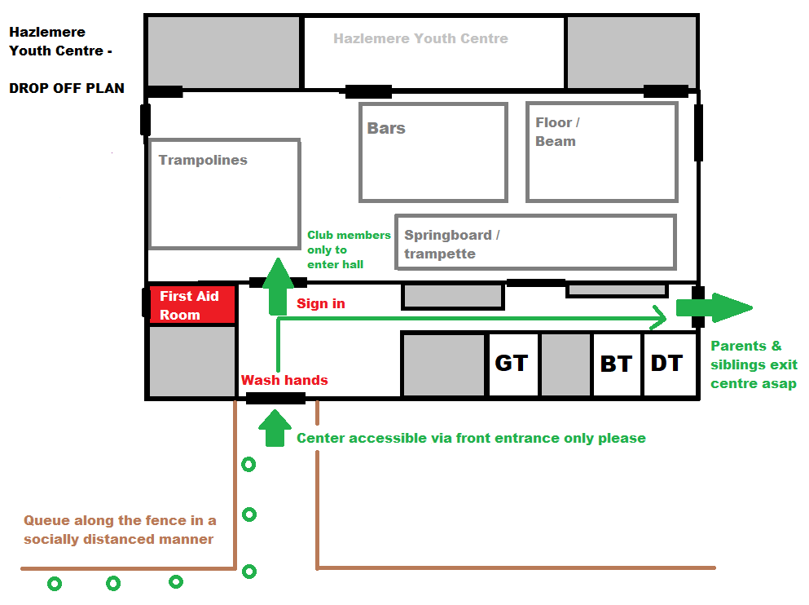

DURING SESSIONS

- When the gymnasts or trampolinists come into the hall they will need to go straight to the piece of equipment their group will be working on first and put their shoes and water bottle by the side of the hall in that area, 2 m from any other child’s stuff. Coaches can start their gymnasts working on their apparatus straight away and warm up on each apparatus as we will be having no group warm up on the mats at present.

- When coaching you need to have a face mask to hand (round your neck or in a pocket etc) so that you can put it on quickly if there is ever a time when you need to get closer than 2m to a gymnast or another coach for example to comfort them, in case of a first aid incident or if you need to clean the equipment.

- We will have spots set up around the hall for the gymnasts to wait and queue on and there are walkways that coaches and gymnasts can use if they need to move around the gym. It is our responsibility as coaches to make sure that the club members all socially distance during sessions and to keep 2m away from others ourselves. Please make sure you watch the video Ruth has sent around which talks through some of the processes and shows you the new typical hall lay out.

- No manual supporting of gymnasts is currently allowed so we will have to coach verbally and from a distance. To make this possible we will be focusing on basic skills and building the gymnasts strength and flexibility when we initially return to training. With the gymnasts we will be working through some new FUNDAMENTALS awards which are designed to get the gymnasts back in shape but using simple skills that are possible to teach without supporting.

- Our focus needs to be rebuilding the gymnasts confidence, relationships within the group and fun!

- Wherever possible we will keep club members in the same session and group, with the same key group coach throughout the term. We may have to switch this around occasionally if a coach is poorly and needs to self-isolate for 2 weeks etc.

- Equipment will be wiped down by the group coach between each group rotation and children will be expected to sanitize their hands and feet before they take a turn on any equipment.

- Ruth or Tracey will deal with any first aid incidents or any children who may tell you they are feeling poorly. The centres policy is that if anyone starts showing Covid symptoms during a lesson then we all need to pack up and go home and cancel any more sessions that are mean to happen that day. Please note coaches – do not come to club if you are feeling at all poorly!!

TOILETS
- Gymnasts and gymnastics coaches please use the usual Boys and Girls toilets. Please use the walkways through the gym and then these can be accessed via the double doors in the gym opposite the toilets.

- Trampolinists and trampoline coaches please use the disabled toilets at the far end of the corridor. These can be accessed via the hall doors that go out into the café area, then along through the door next to the kitchen. Do not walk through the gym to use the toilets.
PICK UP
- 5 minutes before the end of the session coaches will stop their group and give them all hand sanitizer and with the gymnasts we will rotate around once more to where all the gymnasts belongings are so that they can get shoes and coats on and be standing ready around the hall for when the doors are opened. Once the trampolinists have got their shoes and water bottles they can wait 2m apart along the purple divide ready to be signed out with the gymnasts.

- Pick up from all classes will be from the back right hand side fire exit, marked on the floor plan provided below. The parents will need to queue in a socially distanced manner along the walkway provided across the grass and back out to the road and around onto the path in front of the centre if necessary.

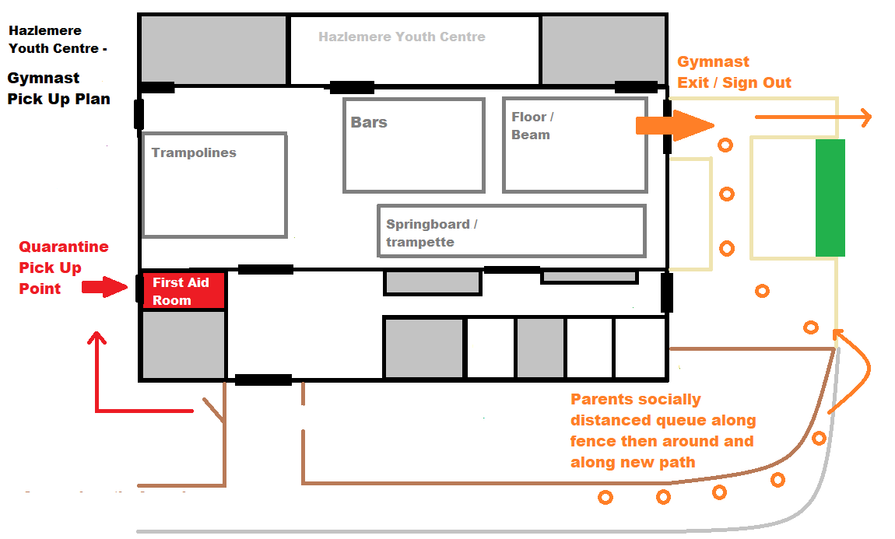
- One coach wearing a face shield will be on sign out at the end of the session and they will sign out all gymnasts and trampolinists.

- In the 10 minutes before the next class arrive all other gymnastics and trampolining coaches will need to then clean the equipment using the mops and clothes provided and sign the cleaning sheet to confirm what they have cleaned.

- Trampoline coaches will be responsible for wiping down the benches, throw in and end deck mats, trampoline bed, and also cleaning the high touch points in the foyer or café area of the centre.

- Gymnastics coaches will be responsible for wiping down the gym mats, bar, beams, springboards and any safety mats used for gym as well as cleaning the high touch point in the toilets and corridor.
Each cleaning box contains multiple small cleaning cloths to use with the spray that can be put in the large flip top bin by the cupboard when dirty. Please use green cloths for the toilet areas, yellow for the corridor and foyer / entrance hall and blue for equipment in the hall.

IF SOMEONE BECOMES POORLY DURING A CLASS
- If an individual becomes unwell with a new continuous cough or a high temperature while at club, we will ring their parents and they will be moved to the quarantine area (the new first aid room as indicated on the floor plan) to wait for their emergency contact person to pick them up. The coach supervising will wear PPE if they are unable to keep a 2m distance for any reason. Pick up will in this case will be from the Quarantine pick up point as indicated on the floor plan above.

- The gymnasts and coaches must then all wash their hands thoroughly and parents called to pick up their children. The centre will then be closed and the coaching team will need to inform any later classes that they are cancelled for that week, then proceed to do a full clean of the equipment being used and the areas of the centre that have been used.

- Anyone who exhibits Covid-19 symptoms should be sent home and self-isolate for 7 days, and book a test. Their household members should self-isolate for 14 days.

- If someone tests negative then is feeling better they can return to club and their household can end their isolation. If they test negative but are still unwell they should not return until they have recovered.

- If someone tests positive, the NHS Test and Trace will speak directly to those they have been in contact with – this may mean those individuals may also need to self-isolate for 14 days.

